2. Material and Methods
Table 1 Overview of compositional differences between diet A and diet B.
Feature | Diet A (High food intake) | Diet B (Low food intake)
Crude Protein / Crude Fat (CP/CF) | 45 / 20 | 45 / 20
Fish Meal Content | Lower | Higher
Land Animal Protein | Higher | Lower
Vitamin and Mineral Levels | Similar | Similar
Amino Acid Specification | Lower in essential amino acids | Higher in essential amino acids

3. Results and Discussion
Table 2 - Summary of number of proteins identified in tissue replicates
Tissue Type | Brain | Liver | Intestine
Diet A Rep1 | 3501 | 2986 | 4295
Diet A Rep2 | 3390 | 2868 | 4351
Diet A Rep3 | 3270 | 3342 | 4413
Diet A Rep4 | 3299 | 3142 | 4482
Diet A-Average | 3365 | 3084 | 4385
Tissue Type | Brain | Liver | Intestine
Diet B Rep1 | 2941 | 2896 | 4493
Diet B Rep2 | 3356 | 3069 | 4545
Diet B Rep3 | 3195 | 2051 | 4484
Diet B Rep4 | 3154 | 2664 | 4471
Diet B-Average | 3161 | 2670 | 4498

Table 3. Comparison of brain samples within and between diets
Diet | Total | Increased | Decreased | Total changed | Percentage
A vs A | 3889 | 101 | 133 | 234 | 6.01%
B vs B | 3817 | 31 | 61 | 92 | 2.41%
A vs B | 3901 | 205 | 302 | 507 | 12.99%

Table 4. Comparison of liver samples within and between diets
Diet | Total | Increased | Decreased | Total changed | Percentage
A vs A | 3649 | 144 | 143 | 287 | 7.86%
B vs B | 3530 | 94 | 110 | 204 | 5.77%
A vs B | 3660 | 235 | 231 | 466 | 12.73%

Table 5. Comparison of intestine samples within and between diets
Diet | Total | Increased | Decreased | Total changed | Percentage
A vs A | 5030 | 48 | 63 | 111 | 2.20%
B vs B | 5003 | 135 | 126 | 261 | 5.21%
A vs B | 5025 | 485 | 349 | 834 | 16.59%

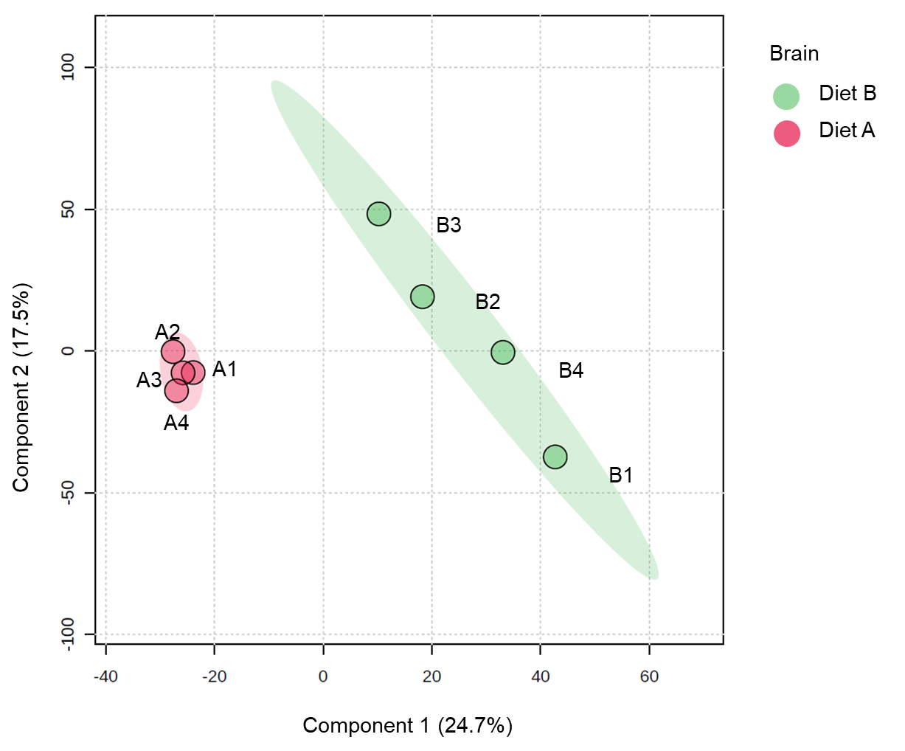
Figure 1. Partial least squares discriminant analysis (PLS-DA) of brain of barramundi fed on diet A and diet B displayed at 95% confidence intervals highlights the clustering of the sample based on their response to different diets.

Figure 2. Volcano plot illustrates significantly differentially abundant proteins in brain. The −log10 (P value) is plotted against the log₂ (fold change: diet B/diet A).

Table 6. Top ten DEPs in brain tissue
Row | Protein ID | Protein Name | Fold change*
Increased abundance in diet B
1 | A0A4W6EX76 | Transporter | 7.49
2 | A0A4W6ER29 | Ferritin | 4.61
3 | A0A4W6D6I8 | Peptidyl-prolyl cis-trans isomerase (PPIase) (EC 5.2.1.8) | 3.64
4 | A0A4W6D1Z6 | Adhesion G protein-coupled receptor L2b, tandem duplicate 1 | 3.54
5 | A0A4W6EE98 | Myosin X, like 1 | 3.42
6 | A0A4W6ETZ5 | Protein tyrosine phosphatase receptor type Nb | 3.42
7 | A0A4W6FSI9 | LIM zinc-binding domain-containing protein | 3.39
8 | A0A4W6EUJ3 | 3-oxoacyl-(acyl-carrier-protein) synthase | 3.33
9 | A0A4W6FB21 | NADH dehydrogenase (ubiquinone) iron-sulfur protein 5 | 3.25
10 | A0A4W6E7W2 | Sodium channel subunit beta-2 isoform X1 | 3.18
Decreased abundance in diet B
1 | A0A4W6DCM7 | Guanine nucleotide-binding protein subunit alpha | 0.02
2 | A0A4W6EGV8 | 1-phosphatidylinositol 4,5-bisphosphate phosphodiesterase | 0.07
3 | A0A4W6DLB9 | Cell adhesion molecule 1a | 0.08
4 | A0A4W6CDB0 | Spermine synthase | 0.08
5 | A0A4W6DXP0 | Guanine nucleotide binding protein (G protein) | 0.09
6 | A0A4W6CNV2 | ATP synthase subunit beta (EC 7.1.2.2) | 0.09
7 | A0A4W6BVV5 | Small ribosomal subunit protein uS2 | 0.09
8 | A0A4W6DBS0 | ADP ribosylation factor like GTPase 3b | 0.10
9 | A0A4W6CBE8 | Solute carrier family 17 member 6 | 0.15
10 | A0A4W6DBM8 | Uncharacterized protein LOC108891021 | 0.16
*Values > 1.3 indicate more abundant in diet B, values < 0.76 indicate less abundant in diet B

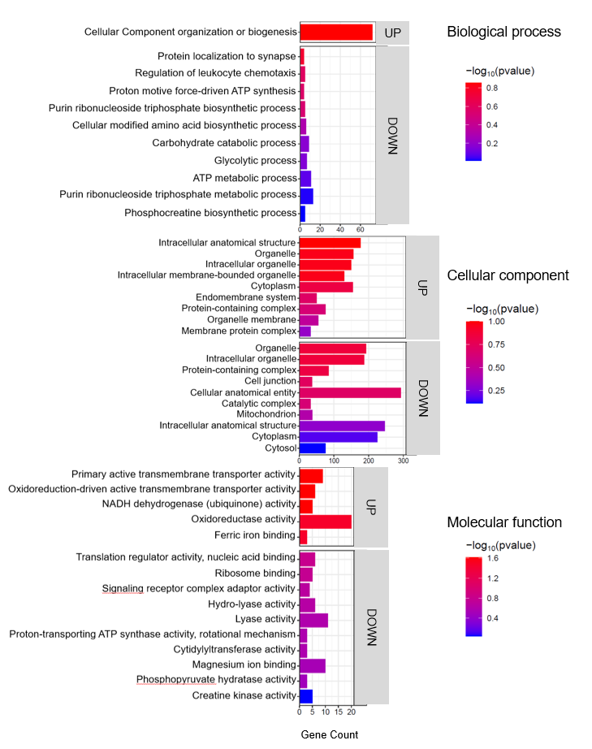
Figure 3. Top enriched GO terms in the DEPs of brain tissue from barramundi. A higher –log₁₀(p-value) (red) indicates greater statistical significance, while lower –log₁₀(p-value) (blue) values indicate less significant enrichment. Up indicates increased abundance in the brain of fish fed on diet B, while Down indicates decreased abundance in the brain of fish fed on diet B.

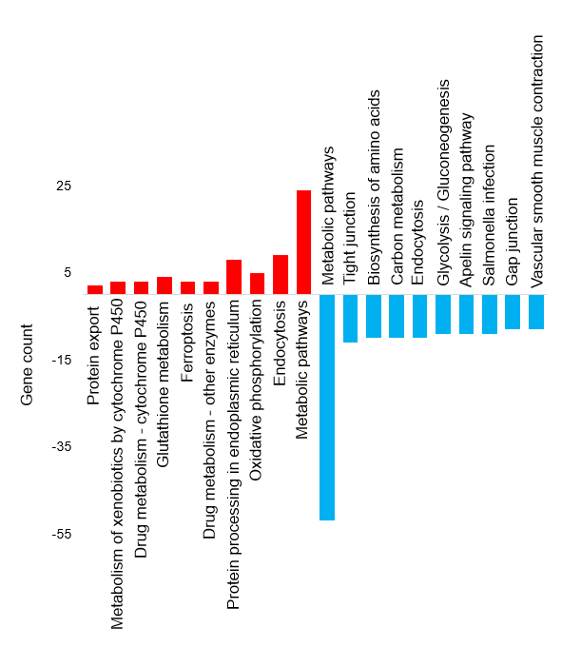
Figure 4. Top KEGG pathways of the differentially abundant proteins in brain tissue

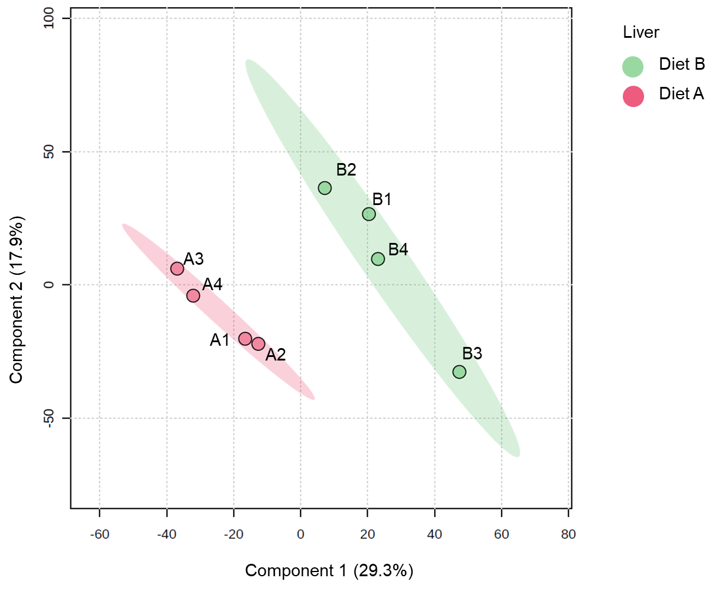
Figure 5. Partial least squares discriminant analysis (PLS-DA) of liver of barramundi fed on diet A and diet B displayed at 95% confidence intervals highlights the clustering of the sample based on their response to different diets.

Figure 6. Volcano plot illustrates significantly differentially abundant proteins in liver. The −log₁₀ (P value) is plotted against the log₂ (fold change: diet B/diet A).

Table 7. Top ten DEPs in the Liver tissue
Row | Protein ID | Protein Name | Fold* change
Increased abundance in diet B
1 | A0A4W6G873 | pancreatic elastase II | 7.13
2 | A0A4W6CY37 | Chymotrypsin-like | 7.04
3 | A0A4W6FQC7 | Vesicle transport protein USE1 | 6.99
4 | A0A4W6D8E6 | Lin-9 DREAM MuvB core complex component | 5.05
5 | A0A4W6BK05 | RNA helicase | 4.86
6 | A0A4W6DXB6 | Dematin actin binding protein | 4.74
7 | A0A4W6FXS8 | Myoglobin | 3.91
8 | A0A4W6CMS6 | O-acyltransferase | 3.89
9 | A0A4W6F0G8 | SPRY domain containing 4 | 3.81
10 | A0A4W6E876 | Ring finger protein 7 | 3.64
Decreased abundance in diet B
11 | A0A4W6CQU6 | C1q domain-containing protein | 0.15
12 | A0A4W6FZS4 | Zinc finger CCCH-type containing 7B | 0.17
13 | Q6ITU9 | Parvalbumin | 0.19
14 | A0A4W6EPI8 | Ig-like domain-containing protein | 0.21
15 | A0A4W6BTM5 | Uncharacterized protein | 0.25
16 | A0A4W6BKR3 | RNA helicase | 0.25
17 | A0A4W6BMF0 | CUB domain-containing protein | 0.26
18 | A0A4W6EUI1 | Si:dkey-69o16.5 | 0.27
19 | A0A4W6FRU8 | Prothrombin | 0.28
20 | A8D3J6 | Lysozyme g | 0.28
*Values > 1.3 indicate more abundant in diet B, values < 0.76 indicate less abundant in diet B

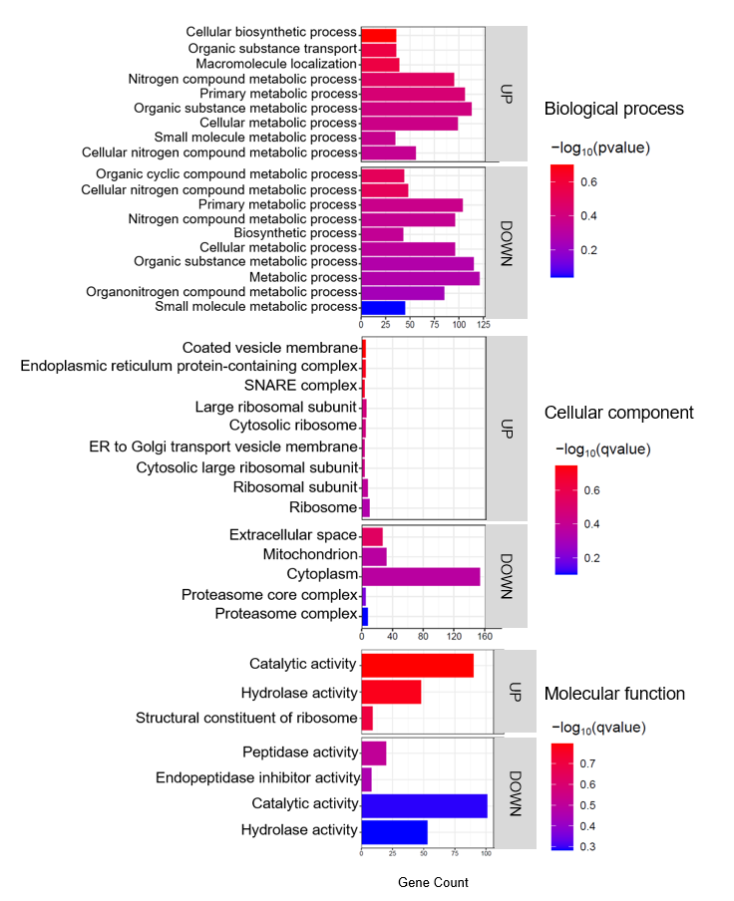
Figure 7. Top enriched GO terms in the DEPs of liver of barramundi. A higher –log₁₀(p-value) (red) indicates greater statistical significance, while lower –log₁₀(p-value) (blue) values indicate less significant enrichment. Up indicates increased abundance in the liver of fish fed on diet B, while Down indicates decreased abundance in the liver of fish fed on diet B.

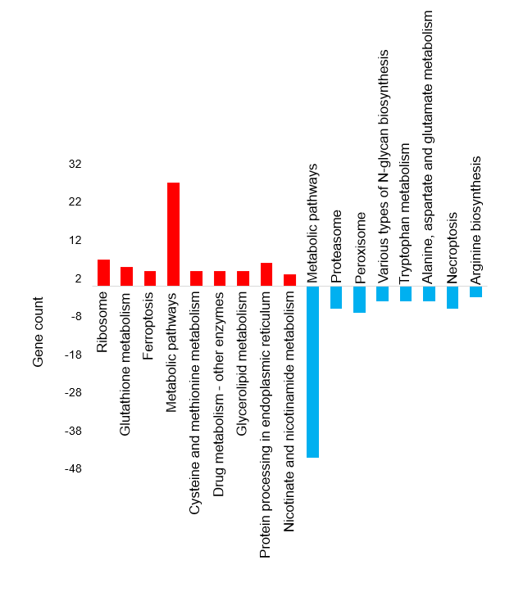
Figure 8. Top KEGG pathways of the differentially abundant proteins in liver tissue

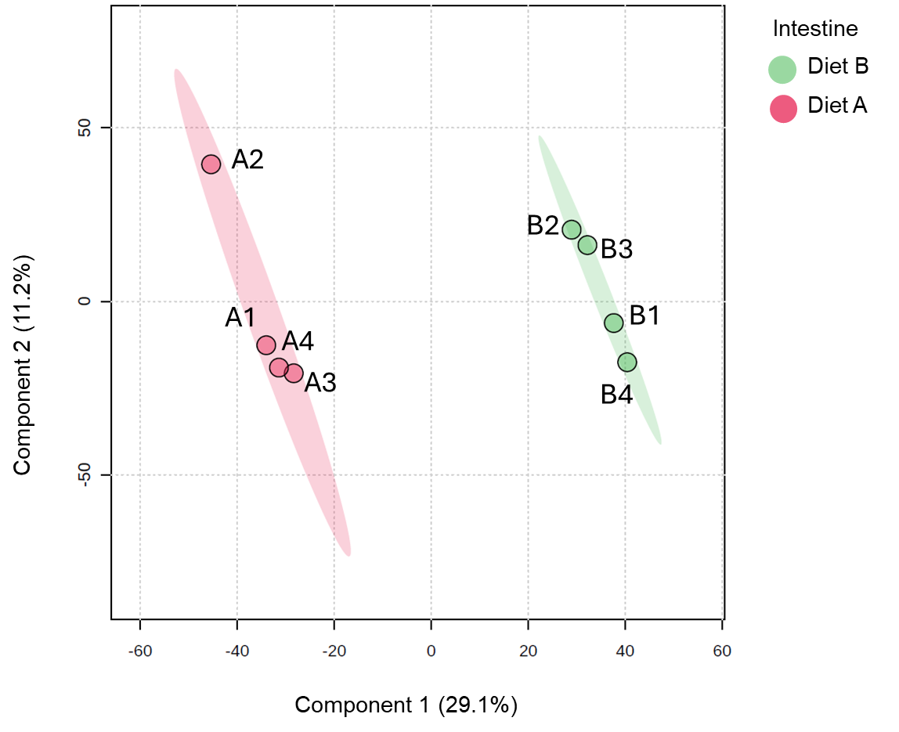

Figure 9. Partial least squares discriminant analysis (PLS-DA) of intestine of barramundi fed on diet A and diet B displayed at 95% confidence intervals highlights the clustering of the sample based on their response to different diets.

Figure 10. Volcano plot illustrates significantly differentially abundant proteins in intestine. The −log₁₀ (P value) is plotted against the log₂ (fold change: diet B/diet A).

Table 8. Top ten DEPs in the Intestine tissue
Row | Protein ID | Protein Name | Fold change*
Increased abundance in diet B
1 | A0A4W6DGN9 | Threonyl carbamoyl-AMP synthase | 9.12
2 | A0A4W6CQR5 | GIT ArfGAP 1 | 6.92
3 | A0A4W6DG98 | NACHT domain-containing protein | 5.29
4 | A0A4W6EI74 | Apolipoprotein Ea | 5.16
5 | A0A4W6FS56 | RUN and SH3 domain containing 1 | 4.74
6 | A0A4W6DP25 | YTH domain-containing family protein | 4.40
7 | A0A4W6D1L2 | Metallo endopeptidase | 4.20
8 | A0A4W6DT98 | DnaJ (Hsp40) homolog, subfamily C, member 8 | 4.03
9 | A0A4W6FGH5 | Bridging integrator 2b | 4.00
10 | A0A4W6CAB3 | AP complex subunit sigma | 3.92
Decreased abundance in diet B
11 | A0A4W6DJG2 | C1q domain-containing protein | 0.06
12 | A0A4W6EI75 | non-specific serine/threonine protein kinase | 0.06
13 | A0A4W6BTQ3 | UPAR/Ly6 domain-containing protein | 0.18
14 | A0A4W6FXK4 | phosphatidylinositol-4,5-bisphosphate 3-kinase | 0.20
15 | A0A4W6G0X6 | H1.0 linker histone | 0.25
16 | A0A4W6CTG1 | Uncharacterized protein | 0.29
17 | A0A4W6F148 | Zmp:0000000846 | 0.29
18 | A0A4W6BT82 | Tyrosine-protein kinase (EC 2.7.10.2) | 0.30
19 | A0A4W6BTD9 | Solute carrier family 25-member 18 | 0.31
20 | A0A4W6ECB4 | Fatty acid-binding protein | 0.31
*Values > 1.3 indicate more abundant in diet B, values < 0.76 indicate less abundant in diet B

Figure 11. Top enriched GO terms in the DEPS of the intestine of barramundi. A higher –log₁₀(p-value) (red) indicates greater statistical significance, while lower –log₁₀(p-value) (blue) values indicate less significant enrichment. Up indicates increased abundance in the intestine of fish fed on diet B, while Down indicates decreased abundance in the intestine of fish fed on diet B.

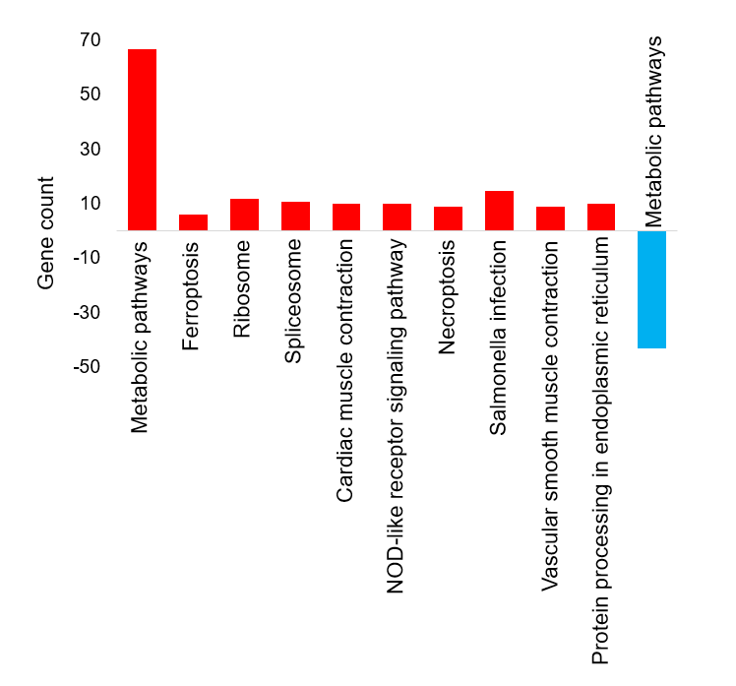
Figure 12. Top KEGG pathways of the differentially abundant proteins in Intestine tissue

Figure 13. Total iron concentration (µg/g) brain tissue of the barramundi fed on diet A and B. Error bars represent the standard deviation.

Figure 14. Total iron concentration (µg/g) liver tissue of the barramundi fed on diet A and B. Bars represent the standard deviation.

Figure 15. Total iron concentration (µg/g) in intestine tissue of the barramundi fed on diet A and B. Bars represent the standard deviation. Asterisk (*) indicates a statistically significant difference between groups as determined by Student’s t-test (p < 0.05).

